**SOLANO COMMUNITY COLLEGE**

**MT 164, PROGRAMMABLE LOGIC CONTROLLERS**

Spring, 2018

PLC PROGRAMMING LAB 8 - SUBROUTINES

**Catharine Crayne**

**04/08/2018**

**OBJECTIVE**:

1. To write a ladder logic program the will control a DC Servo Motor.

**MATERIALS**: Micrologix 1100 Trainer Unit

**SAFETY AND EQUIPMENT NOTES:**

1. Turn off trainer when attaching wires

**PROCEDURE**:

**Part 1: Light Flasher**

1. Design a ladder logic program that will latch a Flashing green pilot light, on and off (once every 2 seconds), when a green pushbutton is pressed and released. When the NC E-Stop button is pressed, the Green light should go off and the Red Light should be ON and stay ON
2. With your Micrologix PLC Trainer, wire the two lights, E-Stop, and Green pushbutton.
3. Download your program to your Micrologix PLC trainer. Verify that it works. Document your program and setup.

**Part 2: Light Flasher**

1. Now modify your program so that the program portion that runs the flashing of the light is in its own subroutine.
2. Download your program to your Micrologix PLC trainer. Verify that it works. Document your program.

**Part 3: Any Light Flasher**

1. Now modify your program so that the subroutine is generic for any light so that when the E-Stop button or the green button is pressed corresponding light flashes. Hint: let the flasher subroutine flash a bit instead of a light output.
2. Download your program to your Micrologix PLC trainer. Verify that it works. Document your program.

**Part 4: Modifying a previous program**

1. Find a previous program and rewrite it using a subroutine(s). Document the new program. You don’t need to wire up a trainer for this.

**RESULTS - DATA**

Part 1: Snapshot of my program.

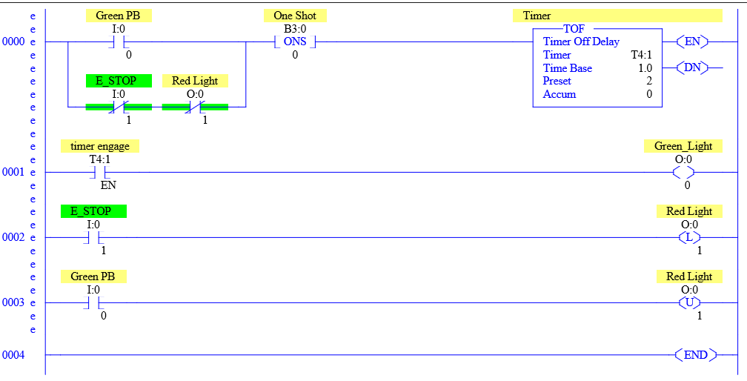

Part 2: Snapshot of my program

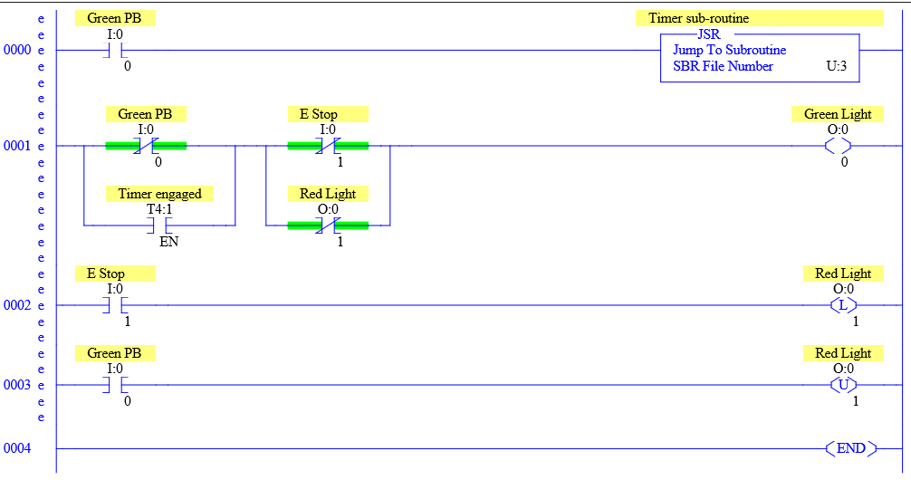

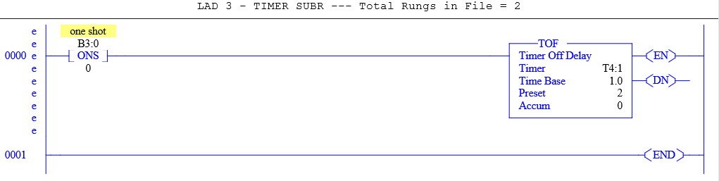

Part 3: Snapshot of my program

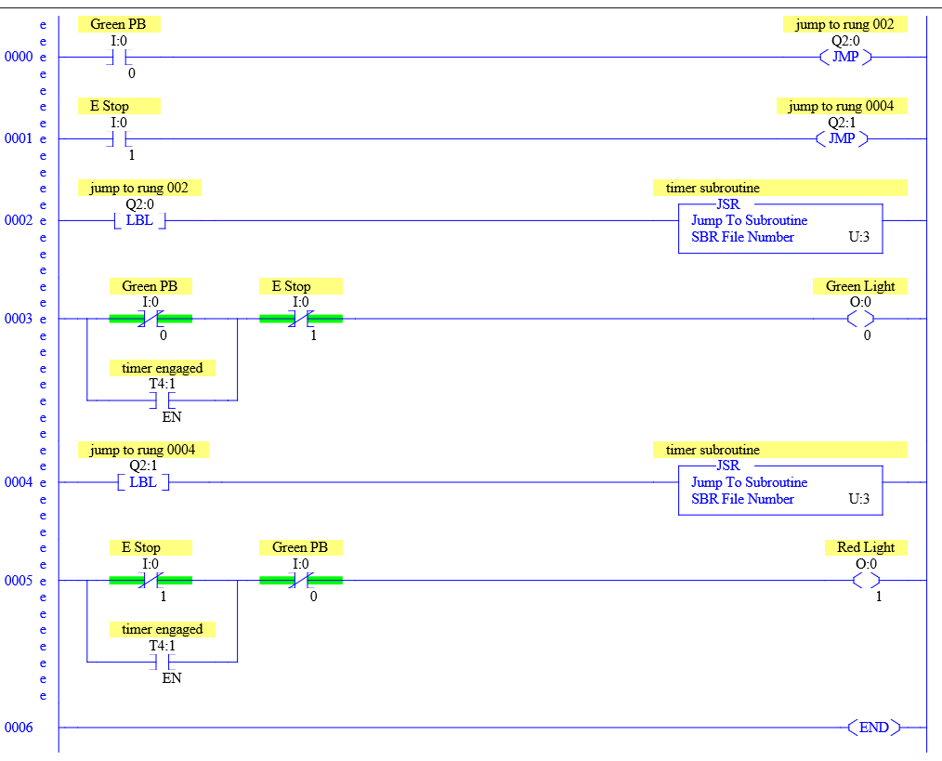

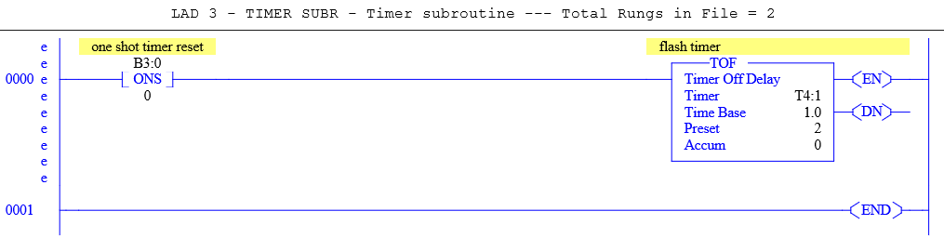

**OBSERVATIONS**

Part 1 Step 2: Picture of our setup

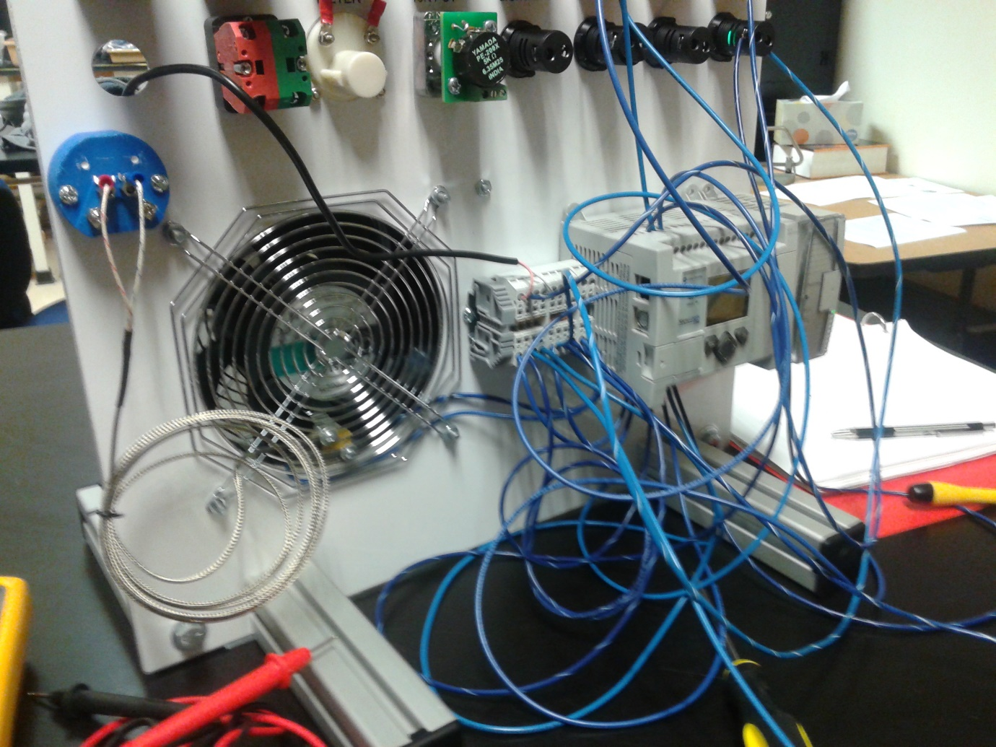

**ANALYSIS QUESTIONS:**

1. How does using subroutines help with the readability or troubleshooting of a program?

*When programs are written with subroutines, each subroutine can be tested individually for functionality. A subroutine can make the program easier to read because it cuts down on the amount of coding required because the same subroutine can be called more than once in the same program.*

1. Can multiple subroutines be called within the main program? Can subroutines be called from inside another subroutine?

*Yes, multiple subroutines can be called within the same program. Yes, subroutines can be nested.*

1. Why is the RET command not a requirement for a subroutine?

*The scan returns from the end of the file if there is no RET instruction. The RET may be conditional, so the processor omits the balance of a subroutine only if its rung condition is true.*